**Unit: Manual Motor Controls Test: 6**

**Motor Nameplates and Three Phase Motors CLO#: 1**

Name ______________________________ Date ______________

**Instructions**

Select the best answer for each multiple-choice question below.

1. A motor’s RPM rating is determined when
   1. Maximum Applied Voltage
   2. When the motor is under full load
   3. Sea Level
   4. When the motor is below FLA
2. List three general types of three-phase motors.
   1. Squirrel cage, shunt-wound, asynchronous motors
   2. Induction, wound rotor and synchronous motors
   3. Dual-voltage, wound rotor and shunt-wound
   4. None of the above
3. What is the purpose of the laminated iron plates within the rotor?
   1. Aid in electromagnetic induction
   2. Reduce Eddy-currents
   3. Reduce hysteresis
   4. B and C
   5. All the above
4. Most industrial motors are of what type?
   1. Single-phase squirrel cage
   2. Three-phase induction
   3. Split-phase wire-wound
   4. Single-phase shunt-wound
5. Which component of a three-phase motor produces the mechanical energy?
   1. Rotor
   2. Squirrel cage
   3. Stator
   4. End Bells
6. If an application requires 1.1 horsepower, it is better to purchase a 1HP motor with a SF of 1.25 than to purchase a 1.5HP with a SF of 1.0.
   1. True
   2. False
7. If a motor has an enclosure type of ODP, what does that indicate?
   1. Outdoor Protected
   2. Open Drip-proof
   3. Oxidized Dielectric Protected
   4. Open Door Plenum
8. What is motor slip?
   1. The difference between the power input to a motor and the actual shaft RPM
   2. The difference between a motors synchronous speed and actual shaft RPM
   3. The difference between the voltage input to a motor and the actual shaft RPM
   4. The difference between the current input to a motor and the actual shaft RPM
9. What does FLA indicate?
   1. Flange size
   2. Max Running Current
   3. Fuse Protection
   4. Face mounted
10. Why would it be good the select a motor that has a SF > 1?
    1. Allows winding temperatures to be cooler.
    2. Protects against heat spikes
    3. Bearings will last longer
    4. A and B
    5. All the above
11. What is the effect of operating a motor above its HP but within its SF?
    1. Causes a reduction in motor RPM
    2. Will reduce Life Span
    3. Causes the motor’s efficiency to decrease
    4. A and C
    5. All the above
12. What is motor Efficiency?
    1. How fast the shaft turns verses the motors rated RPM
    2. How well the motor translates electrical power into rotational power
    3. How quickly the motor gets to full speed on startup
    4. How often the motor needs to rest
13. If a motor is not continuous duty, it is designated as?
    1. Partial duty
    2. Service duty
    3. Intermittent duty
    4. B and C
    5. All the above
14. When a motor is rated for inverter duty, what does that indicate?
    1. It can be used on a solar system
    2. It can be used with a variable frequency drive.
    3. It is a DC motor that will accept an AC input source
    4. It is reversible
15. All manufactures follow the NEMA guidelines when designing their motor nameplates.
    1. True
    2. False
16. A motors *Power Factor (PF)* is useful to determine
    1. The motors efficiency
    2. The motors power requirements
    3. The overall quality of the motor
    4. All of the above
17. When a motor’s nameplate lists AMPS, what does that designate?
    1. Start-up current
    2. Full Load current
    3. Current after startup
    4. Locked rotor current
18. A motor has a *Type*. What does this signify?
    1. The type of enclosure the motor has
    2. It’s construction
    3. The means by which the motor is mounted
    4. The type of insulation of the windings

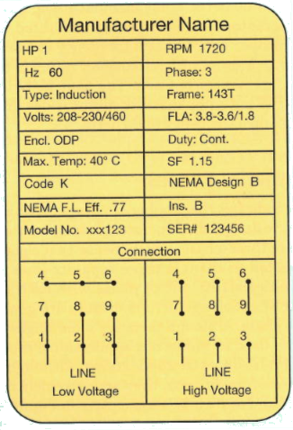

1. What is the horsepower for this motor? __________
2. How many watts should this motor dissipate? ______________
3. What nominal voltage level would you use to connect to this motor to its higher low-voltage setting? ___________
4. What is the acceptable range of voltage input to this motor connected to that voltage range? _______ to _______
5. What is the RPM for this motor? ____________
6. Based on the above RPM, how many poles would this motor have? _______
7. What is its percentage slip? __________
8. What is the service factor of this motor? __________
9. What is the maximum horsepower output of this motor? _________
10. It is safe to run this motor at its max HP for extended periods of time.
    1. True
    2. False
11. Draw a schematic to the right of the motor contactor that indicates its internal components.



1. Construct the formulas for the control schematic below. HINT: There shall be separate formulas for M1, the red light and the yellow light. (M1 and green light formulas are the same)

